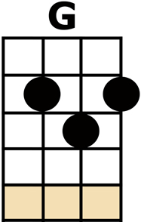
ANY DREAM WILL DO

[No Chord] I CLOSED MY [G] EYES,
[D] DREW BACK THE [G] CURTAIN
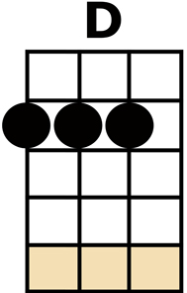
[C] TO SEE FOR [G] CERTAIN
[D] WHAT I THOUGHT I [G] KNEW
[D] FAR FAR A-[G]-WAY, [D] SOMEONE WAS [G] WEEPING
[C] BUT THE WORLD WAS [G] SLEEPING
[D] ANY DREAM WILL [G] DO [D]
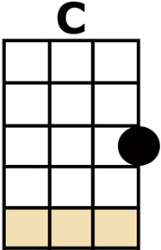
I WORE MY [G] COAT, [D] WITH GOLDEN [G] LINING
[C] BRIGHT COLOURS [G] SHINING,
[D] WONDERFUL AND [G] NEW
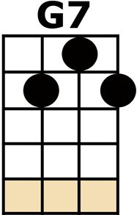
[D] AND IN THE [G] EAST, [D] THE DAWN WAS [G] BREAKING
[C] AND THE WORLD WAS [G] WAKING
[D] ANY DREAM WILL [G] DO [G7]

{Single Strums} A [C/] CRASH OF DRUMS, A [C/] FLASH OF LIGHT
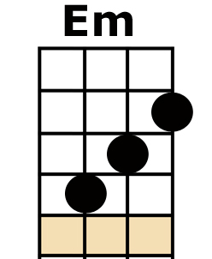
MY [C/] GOLDEN COAT FLEW [C/] OUT OF SIGHT
{Normal Strums} THE [G] COLOURS FADED [Em] INTO DARKNESS
[A7] I WAS LEFT A-[D]-LONE

[No Chord] MAY I RE-[G]-TURN [D] TO THE BE-[G]-GINING
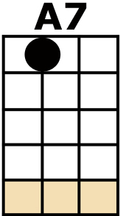
[C] THE LIGHT IS [G] DIMMING, [D] AND THE DREAM IS [G] TOO
[D] THE WORLD AND [G] I, [D] WE ARE STILL [G] WAITING
[C] STILL HESI-[G]-TATING
[D] ANY DREAM WILL [G] DO [D]

INSTRUMENTAL (SAME AS 2nd VERSE):
[G] [D] [G] [C] [G] [D] [G] [D]
[G] [D] [G] [C] [G] [D] [G] [G7]

{Single Strums} A [C/] CRASH OF DRUMS, A [C/] FLASH OF LIGHT
MY [C/] GOLDEN COAT FLEW [C/] OUT OF SIGHT
{Normal Strums} THE [G] COLOURS FADED [Em] INTO DARKNESS
[A7] I WAS LEFT A-[D]-LONE

[No Chord] MAY I RE-[G]-TURN [D] TO THE BE-[G]-GINING
[C] THE LIGHT IS [G] DIMMING, [D] AND THE DREAM IS [G] TOO
[D] THE WORLD AND [G] I, [D] WE ARE STILL [G] WAITING
[C] STILL HESI-[G]-TATING
[D] ANY DREAM WILL [G] DO
[D] ANY DREAM WILL [G] DO
[D] ANY DREAM WILL [G] DO

