BAD MOON RISING [G//] [G//] [D//] [C//] [G//] [G] repeat

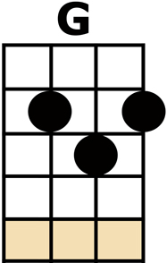
[G] I SEE THE [D] BAD [C] MOON A-[G] RISING [G]
[G] I SEE [D] TROUBLE [C] ON THE [G] WAY [G]
[G] I SEE [D] EARTH-[C]-QUAKES AND [G] LIGHTNING [G]
[G] I SEE [D] BAD [C] TIMES TO-[G]-DAY [G]

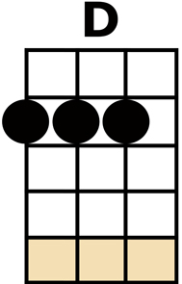
[C] DON'T GO AROUND [C] TONIGHT IT'S
[G] BOUND TO TAKE YOUR [G] LIFE
[D] THERE'S A [C] BAD MOON ON THE [G] RISE [G]
[C] DON'T GO AROUND [C] TONIGHT IT'S
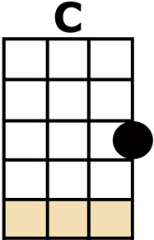
[G] BOUND TO TAKE YOUR [G] LIFE
[D] THERE'S A [C] BAD MOON ON THE [G] RISE [G]

[G] I HEAR [D] HURRI-[C]-CANES A-[G]-BLOWING [G]
[G] I KNOW THE [D] END IS [C] COMING [G] SOON [G]
[G] I FEAR [D] RIVERS [C] OVER-[G]-FLOWING [G]
[G] I HEAR THE [D] VOICE OF [C] RAGE AND [G] RUIN [G]

[C] DON'T GO AROUND [C] TONIGHT IT'S
[G] BOUND TO TAKE YOUR [G] LIFE
[D] THERE'S A [C] BAD MOON ON THE [G] RISE [G]
[C] DON'T GO AROUND [C] TONIGHT IT'S
[G] BOUND TO TAKE YOUR [G] LIFE
[D] THERE'S A [C] BAD MOON ON THE [G] RISE [G]

[G] HOPE YOU HAVE [D] GOT YOUR [C] THINGS TO-[G]-GETHER [G]
[G] HOPE YOU ARE [D] QUITE PRE-[C]-PARED TO [G] DIE [G]
[G] LOOKS LIKE WE'RE [D] IN FOR [C] NASTY [G] WEATHER [G]
[G] ONE EYE IS [D] TAKEN [C] FOR AN [G] EYE [G]

CHORUS then FALSE ENDING: [C/] [G/] ... wait ...

"--,2-,3-,4"
[C] DON'T GO AROUND [C] TONIGHT IT'S
[G] BOUND TO TAKE YOUR [G] LIFE
[D] THERE'S A [C] BAD MOON ON THE [G] RISE [G]
[C] DON'T GO AROUND [C] TONIGHT IT'S
[G] BOUND TO TAKE YOUR [G] LIFE
[D] THERE'S A [C] BAD MOON ON THE [G] RISE [C/] [G/]

