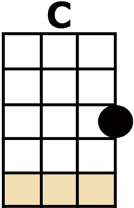
CITY OF NEW ORLEANS

[C] RIDING ON THE [G] CITY OF NEW [C] ORLEANS
[Am] ILLINOIS CENTRAL [F] MONDAY MORNING [C] RAIL [G]
[C] FIFTEEN CARS AND [G] FIFTEEN RESTLESS [C] RIDERS
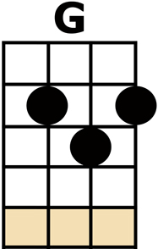
[Am] THREE CONDUCTORS AND
[G] TWENTY-FIVE SACKS OF [C] MAIL
ALL A-[Am]-LONG THE SOUTH-BOUND ODYSSEY
THE [Em] TRAIN PULLS OUT OF KENKAKEE
[G] ROLLS ALONG PAST HOUSES FARMS AND [D] FIELDS
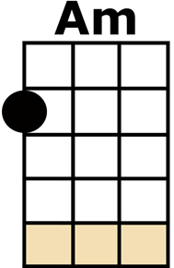
[Am] PASSING TRAINS THAT HAVE NO NAME
[Em] FREIGHT YARDS FULL OF OLD BLACK MEN
AND THE [G] GRAVEYARDS OF [G7] RUSTED AUTOMO-[C]-BILES

CHORUS:
[F] GOOD MORNING A-[G]-MERICA, HOW [C] ARE YOU?
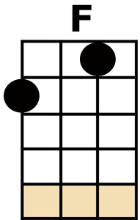
SAY [Am] DON'T YOU KNOW ME, [F] I'M YOUR NATIVE [C] SON [G]
I'M THE [C] TRAIN THEY CALL
THE [G] CITY OF NEW [Am] ORLEANS [D7]
I'LL BE [Bb] GONE FIVE [F] HUNDRED [G] MILES
WHEN THE DAY IS [C] DONE

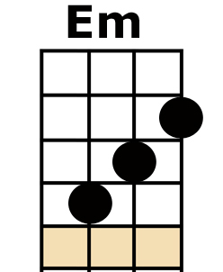
DEALING [C] CARD GAMES WITH THE
[G] OLD MEN IN THE [C] CLUB CAR
[Am] PENNY A POINT AIN'T [F] NO-ONE KEEPING [C] SCORE [G]
[C] PASS THE PAPER [G] BAG THAT HOLDS THE [C] BOTTLE
[Am] FEEL THE WHEELS [G] RUMBLING 'NEATH THE [C] FLOOR
AND THE [Am] SONS OF PULLMAN PORTERS AND
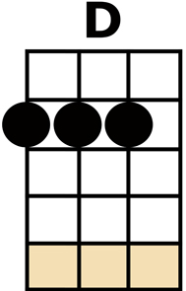
THE [Em] SONS OF ENGINEERS
RIDE THEIR [G] FATHER'S MAGIC CARPETS MADE OF [D] STEEL
[Am] MOTHERS WITH THEIR BABES ASLEEP
[Em] ROCKING TO THE GENTLE BEAT
AND THE [G] RHYTHM OF THE [G7] RAILS IS ALL THEY [C] FEEL
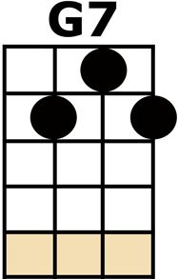
CHORUS

[C] NIGHT TIME ON THE [G] CITY OF NEW [C] ORLEANS
[Am] CHANGING CARS IN [F] MEMPHIS TENNES-[C]-SEE [G]
[C] HALF WAY HOME [G] WE'LL BE THERE BY [C] MORNING
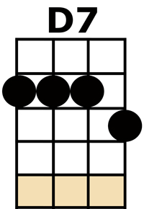
THROUGH THE [Am] MISSISSIPPI DARKNESS
[G] ROLLING DOWN TO THE [C] SEA
BUT [Am] ALL THE TOWNS AND PEOPLE SEEM TO
[Em] FADE INTO A BAD DREAM
AND THE [G] STEEL RAIL STILL AIN'T HEARD THE [D] NEWS
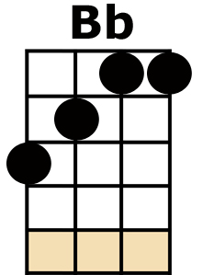
THE CON-[Am]-DUCTOR SINGS HIS SONGS AGAIN
THE [Em] PASSENGERS WILL PLEASE REFRAIN
THIS [G] TRAIN GOT THE DISAP-[G7]-PEARING RAILROAD [C] BLUES

[F] GOOD NIGHT A-[G]-MERICA, HOW [C] ARE YOU?
SAY [Am] DON'T YOU KNOW ME, [F] I'M YOUR NATIVE [C] SON [G]
I'M THE [C] TRAIN THEY CALL THE [G] CITY OF NEW [Am] ORLEANS [D7]
I'LL BE [Bb] GONE FIVE [F] HUNDRED [G] MILES
WHEN THE DAY IS [C] DONE
I'LL BE [Bb] GONE FIVE [F] HUNDRED [G] MILES
WHEN THE DAY IS [C] DONE

