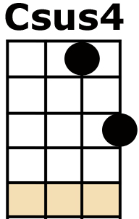
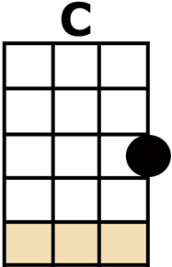
DEDICATED FOLLOWER OF FASHION

INTRO: single strums [C/] [C/] [Csus4/] [Csus4/] [C/]
(No Chord) THEY SEEK HIM [G] HERE THEY SEEK HIM [C] THERE
HIS CLOTHES ARE [G] LOUD BUT NEVER [C] SQUARE
[F] IT WILL MAKE OR BREAK HIM
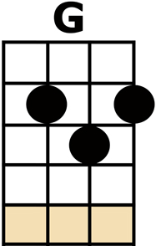
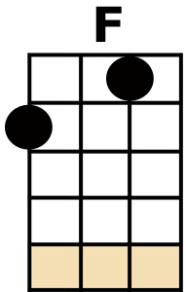
SO HE'S [C] GOT TO BUY THE [A7] BEST 'COS HE'S A
[D] DEDICATED [G7] FOLLOWER OF [C] FASHION [Csus4] [C/]

(No Chord) AND WHEN HE [G] DOES HIS LITTLE [C] ROUNDS
ROUND THE BOU-[G]-TIQUES OF LONDON [C] TOWN
[F] EAGERLY PURSUING ALL THE [C] LATEST FANCY [A7] TRENDS
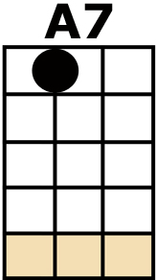
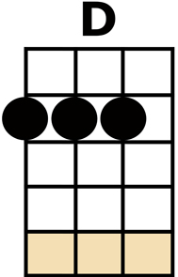
'COS HE'S A [D] DEDICATED [G7] FOLLOWER OF [C] FASHION
[Csus4] [C/]

OH YES HE [G] IS (OH YES HE IS)
OH YES HE [C] IS (OH YES HE IS)
HE [F] THINKS HE IS A FLOWER
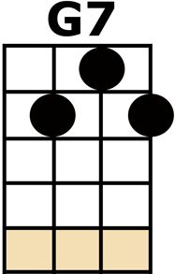
TO BE [C] LOOKED AT [Csus4] [C]
AND [F] WHEN HE PULLS HIS FRILLY NYLON
[C] PANTIES RIGHT UP [A7] TIGHT HE FEELS A
[D] DEDICATED [G7] FOLLOWER OF [C] FASHION [Csus4] [C/]

OH YES HE [G] IS (OH YES HE IS)
OH YES HE [C] IS (OH YES HE IS)
THERE'S [F] ONE THING THAT HE LOVES AND THAT IS [C] FLATTERY
[Csus4] [C]
[F] ONE WEEK HE'S IN POLKA DOTS THE
[C] NEXT WEEK HE'S IN [A7] STRIPES 'COS HE'S A
[D] DEDICATED [G7] FOLLOWER OF [C] FASHION [Csus4] [C/]

(No Chord) THEY SEEK HIM [G] HERE THEY SEEK HIM [C] THERE
IN REGENT'S [G] STREET AND LEICESTER [C] SQUARE
[F] EVERYWHERE THE CARNABETIAN [C] ARMY MARCHES [A7] ON
EACH ONE A [D] DEDICATED [G7] FOLLOWER OF [C] FASHION
[Csus4] [C/]

OH YES HE [G] IS (OH YES HE IS)
OH YES HE [C] IS (OH YES HE IS)
HIS [F] WORLD IS BUILT ROUND
DISCOTHEQUES AND [C] PARTIES [Csus4] [C]
THIS [F] PLEASURE SEEKING INDIVIDUAL
[C] ALWAYS LOOKS HIS [A7] BEST 'COS HE'S A
[D] DEDICATED [G7] FOLLOWER OF [C] FASHION [Csus4] [C/]

OH YES HE [G] IS (OH YES HE IS)
OH YES HE [C] IS (OH YES HE IS)
HE [F] FLITS FROM SHOP TO SHOP JUST LIKE A [C] BUTTERFLY [Csus4] [C]
IN [F] MATTERS OF THE CLOTH HE IS AS [C] FICKLE AS CAN [A7] BE
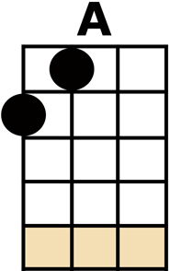
'COS HE'S A [D] DEDICATED [G7] FOLLOWER OF [C] FASHION [A]
HE'S A [D] DEDICATED [G7] FOLLOWER OF [C] FASHION [A]
HE'S A [D] DEDICATED [G] FOLLOWER OF [C] FASHION

OUTRO: single strums [C/] [C/] [Csus4/] [Csus4/] [C/]

