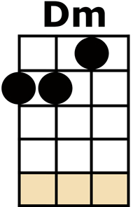
DELILAH

[Dm] I SAW THE LIGHT ON THE NIGHT THAT I
[Dm] PASSED BY HER [A7] WINDOW {Da Da Da Daaa}
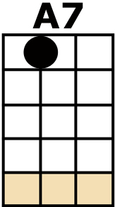
[Dm] I SAW THE FLICKERING SHADOWS OF
[Dm] LOVE ON HER [A7] BLIND {Da Da Da Daaa}
[D] SHE [D7] WAS MY [Gm] WOMAN
[Dm] AS SHE DECEIVED ME I
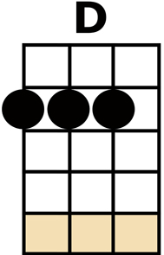
[A7/] WATCHED AND WENT OUT OF MY [Dm] MIND [C7]

[F] MY, MY, MY, DE-[C]-LILAH {Da Da Da Da Da Da Da Da Daaa}
[C7] WHY, WHY, WHY, DE-[F]-LILAH {Da Da Da Da Da Da Da Da Daaa}
I COULD [F7] SEE,
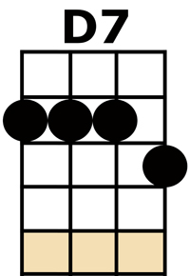
THAT [Bb] GIRL WAS NO GOOD FOR [Gm] ME
BUT [F] I WAS LOST LIKE A
[C/] SLAVE THAT NO ONE COULD [F] FREE [A7]

[Dm] AT BREAK OF DAY WHEN THAT
[Dm] MAN DROVE AWAY I WAS [A7] WAITING {Da Da Da Daaa}
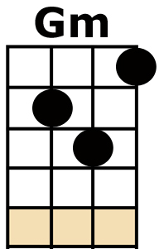
[Dm] I CROSSED THE STREET TO HER HOUSE AND SHE
[Dm] OPENED THE [A7] DOOR {Da Da Da Daaa}
[D] SHE [D7] STOOD THERE [Gm] LAUGHING {Ha Ha Ha Haaa}
[Dm] I FELT THE KNIFE IN MY [A7/] HAND,
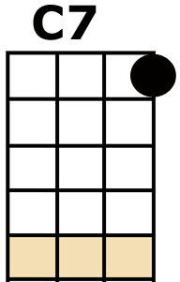
AND SHE LAUGHED NO [Dm] MORE [C7]

[F] MY, MY, MY, DE-[C]-LILAH {Da Da Da Da Da Da Da Da Daaa}
[C7] WHY, WHY, WHY, DE-[F]-LILAH {Da Da Da Da Da Da Da Da Daaa}
SO BE-[F7]-FORE
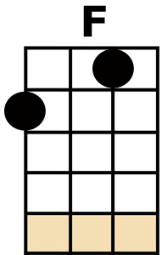
THEY [Bb] COME TO BREAK DOWN THE [Gm] DOOR
FOR-[F]-GIVE ME DELILAH
I [C] JUST COULDN'T TAKE ANY [F] MORE [A7]

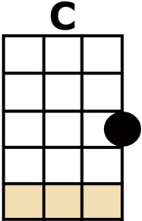
KAZOO INSTRUMENTAL VERSE [Dm] [A7] [Dm] [A7]

[D] SHE [D7] STOOD THERE [Gm] LAUGHING {Ha Ha Ha Haaa}
[Dm] I FELT THE KNIFE IN MY [A7/] HAND,
AND SHE LAUGHED NO [Dm] MORE [C7]
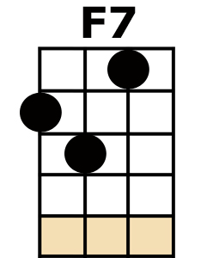
[F] MY, MY, MY, DE-[C]-LILAH {Da Da Da Da Da Da Da Da Daaa}
[C7] WHY, WHY, WHY, DE-[F]-LILAH {Da Da Da Da Da Da Da Da Daaa}
SO BE-[F7]-FORE
THEY [Bb] COME TO BREAK DOWN THE [Gm] DOOR
FOR-[F]-GIVE ME DELILAH
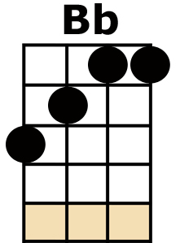
I [C] JUST COULDN'T TAKE ANY [F] MORE [A7]
FOR-[Dm]-GIVE ME DELILAH
I [A7] JUST COULDN'T TAKE ANY [Dm] MORE [G][D][A/][Dm/]

