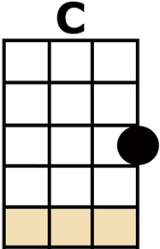
EIGHT DAYS A WEEK

[C] [D7] [F] [C]
[C] OOH I NEED YOUR [D7] LOVE BABE
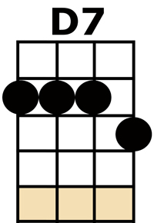
[F] GUESS YOU KNOW IT'S [C] TRUE
[C] HOPE YOU NEED MY [D7] LOVE BABE
[F] JUST LIKE I NEED [C] YOU (WO-WOH)

[Am/] HOLD [Am/] ME, [Am//] [F/] LOVE [F/] ME [F//]
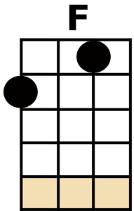
[Am/] HOLD [Am/] ME, [Am//] [D7/] LOVE [D7/] ME [D7//]
[C] AIN'T GOT NOTHIN' BUT [D7] LOVE BABE
[F] EIGHT DAYS A [C] WEEK

[C] LOVE YOU EVERY [D7] DAY GIRL
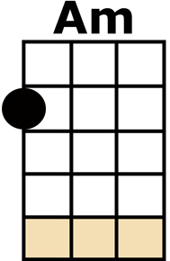
[F] ALWAYS ON MY [C] MIND
[C] ONE THING I CAN [D7] SAY GIRL
[F] LOVE YOU ALL THE [C] TIME (WO-WOH)

[Am/] HOLD [Am/] ME, [Am//] [F/] LOVE [F/] ME [F//]
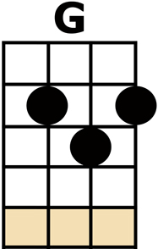
[Am/] HOLD [Am/] ME, [Am//] [D7/] LOVE [D7/] ME [D7//]
[C] AIN'T GOT NOTHIN' BUT [D7] LOVE BABE
[F] EIGHT DAYS A [C] WEEK

[G] EIGHT DAYS A WEEK I [Am] LOVE YOU
[D7] EIGHT DAYS A WEEK IS [F] NOT ENOUGH TO [G7] SHOW I CARE
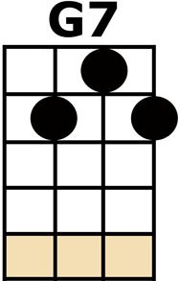
[C] OOH I NEED YOUR [D7] LOVE BABE
[F] GUESS YOU KNOW IT'S [C] TRUE
[C] HOPE YOU NEED MY [D7] LOVE BABE
[F] JUST LIKE I NEED [C] YOU (WO-WOH)

[Am/] HOLD [Am/] ME, [Am//] [F/] LOVE [F/] ME [F//]
[Am/] HOLD [Am/] ME, [Am//] [D7/] LOVE [D7/] ME [D7//]
[C] AIN'T GOT NOTHIN' BUT [D7] LOVE BABE
[F] EIGHT DAYS A [C] WEEK

[G] EIGHT DAYS A WEEK I [Am] LOVE YOU
[D7] EIGHT DAYS A WEEK IS [F] NOT ENOUGH TO [G7] SHOW I CARE
[C] LOVE YOU EVERY [D7] DAY GIRL
[F] ALWAYS ON MY [C] MIND
[C] ONE THING I CAN [D7] SAY GIRL
[F] LOVE YOU ALL THE [C] TIME (WO-WOH)

[Am/] HOLD [Am/] ME, [Am//] [F/] LOVE [F/] ME [F//]
[Am/] HOLD [Am/] ME, [Am//] [D7/] LOVE [D7/] ME [D7//]
[C] AIN'T GOT NOTHIN' BUT [D7] LOVE BABE
[F] EIGHT DAYS A [C] WEEK
[F] EIGHT DAYS A [C] WEEK
[F] EIGHT DAYS A [C] WEEK ... [C] [D7] [F] [C/]

