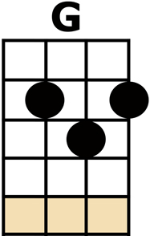
FIELDS OF ATHENRY

[G] BY A LONELY PRISON WALL,
I [C] HEARD
A YOUNG GIRL [G] CALL-[D]-ING [D]
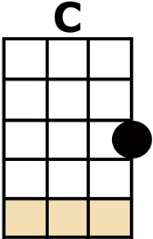
[G] "MICHAEL THEY HAVE
[C] TAKEN YOU A-[D]-WAY.
FOR YOU [G] STOLE TREVELYN'S [C] CORN
SO THE [G] YOUNG MIGHT SEE THE [D] MORN,
NOW A PRISON SHIP LIES
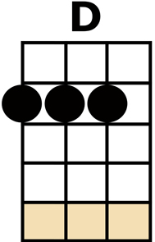
WAITING IN THE [G] BAY"

CHORUS:
[G] LOW [C] LIE
THE [G] FIELDS OF ATHEN-[Em]-RY
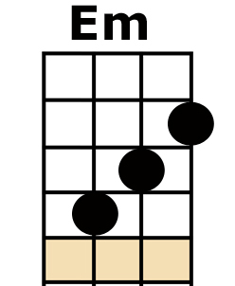
WHERE [G] ONCE WE WATCHED
THE [Em] SMALL FREE BIRDS [D] FLY
OUR [G] LOVE WAS ON THE [C] WING
WE HAD [G] DREAMS AND SONGS TO [D] SING
IT'S SO LONELY ROUND
THE FIELDS OF ATHEN-[G]-RY

[G] BY A LONELY PRISON WALL,
I [C] HEARD
A YOUNG MAN [G] CALL-[D]-ING [D]
[G] "NOTHING MATTERS
[C] MARY WHEN YOU'RE [D] FREE.
AGAINST THE [G] FAMINE AND THE [C] CROWN,
I RE-[G]-BELLED, THEY CUT ME [D] DOWN,
NOW YOU MUST RAISE
OUR CHILD WITH DIGNI-[G]-TY"

CHORUS

[G] BY A LONELY HARBOR WALL
SHE [C] WATCHED
THE LAST STAR [G] FALL-[D]-ING [D]
AS THE [G] PRISON SHIP
SAILED [C] OUT AGAINST THE [D] SKY
FOR SHE [G] LIVED IN HOPE AND [C] PRAYED
FOR HER [G] LOVE IN BOTANY [D] BAY
IT'S SO LONELY ROUND
THE FIELDS OF ATHEN-[G]-RY

CHORUS

IT'S SO [D] LONELY ROUND
THE FIELDS OF ATHEN-[G]-RY [C/] [G/]

