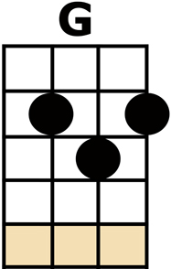
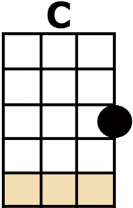
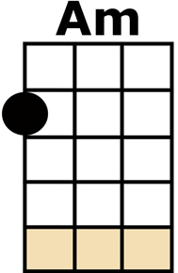
HOT LOVE

WELL SHE'S MY [G] WOMAN OF GOLD
AND SHE'S NOT VERY OLD - A HA HA {OOOOOOOH}
WELL SHE'S MY [C] WOMAN OF GOLD
AND SHE'S [Am] NOT VERY OLD - A HA [G] HA {OOOOOOOH}
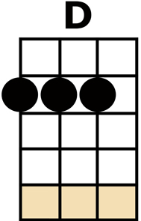
I DON'T [D] MEAN TO BE BOLD,
AH-BUT-A [C] MAY I HOLD YOUR [G] HAND?
WELL SHE [G] AIN'T NO WITCH
AND I LOVE THE WAY SHE TWITCH - A HA HA {OOOOOOOH}
WELL SHE [C] AIN'T NO WITCH
AND I [Am] LOVE THE WAY SHE TWITCH - A HA [G] HA {OOOOOOOH}
I'M A [D] LABOURER OF LOVE IN MY
[C] PERSIAN GLOVES - A HA [G] HA
WELL SHE'S [G] FASTER THAN MOST
AND SHE LIVES ON THE COAST - A HA HA {OOOOOOOH}
WELL SHE'S [C] FASTER THAN MOST
AND SHE [Am] LIVES ON THE COAST - A HA [G] HA {OOOOOOOH}
I'M HER [D] TWO-PENNY PRINCE AND I
[C] GIVE HER HOT LOVE - A HA [G] HA
[G/] [G/] [G/] [G/][G/] [G/] [G/] OW!
[G/] [G/] [G/] [G/][G/] [G/] [G/] OW!
[G/] [G/] [G/] [G/][G/] [G/]
[G/] [G/] [G/] [G/][G/] [G/]
G string single notes: 0 - 2 - 4
[C] OOOOH OOO [Am] OOOOH OOO [G] OOOOH
G string single notes: 0 - 2 - 4
[C] OOOOH OOO [Am] OOOOH OOO [G] OOOOH

WELL SHE [G] AIN'T NO WITCH
AND I LOVE THE WAY SHE TWITCH - A HA HA {OOOOOOOH}
WELL SHE [C] AIN'T NO WITCH
AND I [Am] LOVE THE WAY SHE TWITCH - A HA [G] HA {OOOOOOOH}
I'M HER [D] TWO-PENNY PRINCE AND I
[C] GIVE HER HOT LOVE - A HA [G] HA
{NO CHORD} LA-LA-LA-[G] LA-LA-LA-LA ....
LA-LA-LA-[G] LA-LA-LA-LA ....
LA-LA-LA-[C] LA-LA-LA-LA ....
[Am] LA-LA-LA-[G] LA-LA-LA-LA ....
[D] OOH OOH, [C] OOH OOH, [G] [D/// /// /// /// /] .... x3

