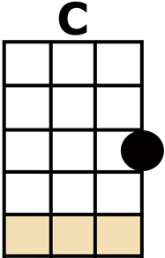
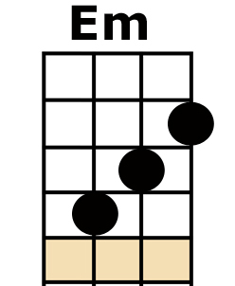
HOLD THE LINE [C] [Em] [Am] [F]

[C] HOLD ON WE JUST HAVE TO [Em] HOLD ON
WE DON'T HAVE TO [Am] CRY --- NO NOT TO-[F]-NIGHT
I KNOW [C] LATELY EVERYTHING SEEMS [Em] CRAZY
PEOPLE WALKING [Am] BY --- JUST GETTING [F] BY
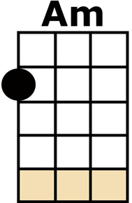
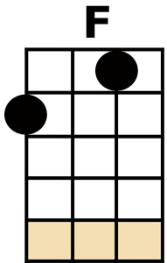
AND [Dm] I-I-I-I JUST [C] WANNA REST MY [G] HEAD [G]
AND [C] LAY DOWN WITH [G] ROSES ON OUR [Am] BED [Am]
THEY [Dm] SAY [C] HEAVEN CAN [G] WAIT
YOU AND [F] I, --- WE'LL SUR-[G]-VIVE

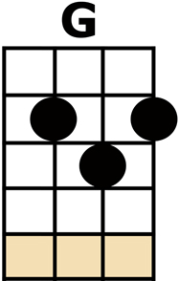
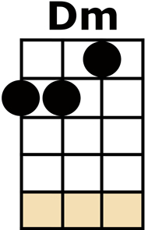
CHORUS:
SOMETIMES WE'RE [C] LOST AND ASTRAY
AND THE [Em] HOPE FAR AWAY,
HOLD THE [Am] LINE, --- WE'LL SUR-[F]-VIVE
SO LET'S JUST [C] SMILE THROUGH THE RAIN
THROUGH THE [Em] HEARTACHE AND PAIN
HOLD THE [Am] LINE --- WE'LL SUR-[F]-VIVE, (WE'LL SURVIVE)
LA LA LA [C] LA LA LA, LA LA LA [Em] LA LA LA
HOLD THE [Am] LINE (HOLD THE LINE), WE'LL SUR-[F]-VIVE, (WE'LL SURVIVE)

[C////] [C////]

[C] SLOW DOWN WE JUST HAVE TO [Em] SLOW DOWN
NOW THEY'RE COMING [Am] FAST, --- WAY TOO [F] FAST
ANOTHER [C] GREY DAY, TECHNICOLOUR, [Em] SAVE ME
PAINTED IN THE [Am] SKY --- WE'RE A-[F]-LIVE
AND [Dm] I-I-I-I JUST [C] WANNA REST MY [G] HEAD [G]
AND [C] LAY DOWN WITH [G] ROSES ON OUR [Am] BED [Am]
THEY [Dm] SAY [C] HEAVEN CAN [G] WAIT
YOU AND [F] I, --- WE'LL SUR-[G]-VIVE

CHORUS

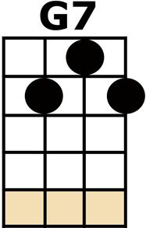
LA LA LA [C] LA LA LA, LA LA LA [Em] LA LA LA
HOLD THE [Am] LINE, WE'LL SUR-[F]-VIVE,

[G] [Am] [F] [F] [G] [Am] [F] [F]
[G] [Am] [C] [Dm] [Em] [G] [G7] [G7] {stop}

[C] HOLD ON WE JUST HAVE TO [Em] HOLD ON
WE DON'T HAVE TO [Am] CRY, NO NOT TO-[F]-NIGHT
I KNOW [C] LATELY EVERYTHING SEEMS [Em] CRAZY
PEOPLE WALKING [Am] BY --- GETTING [F] BY

CHORUS

LA LA LA [C] LA LA LA, LA LA LA [Em] LA LA LA, OH [Am] YEAH,
WE'LL SUR-[F]-VIVE, WE'LL SUR-[C/]-VIVE

