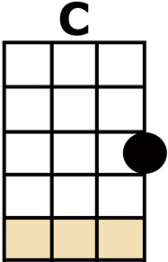
I'M HENRY THE EIGHTH I AM
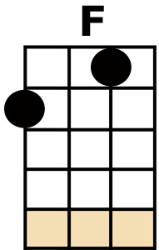
[C] I'M 'ENERY THE EIGHTH, I AM
[F] 'ENERY THE EIGHTH, I [C] AM, I AM
[C] I GOT MARRIED TO THE WIDOW NEXT DOOR
[D] SHE'S BEEN MARRIED SEVEN [G] TIMES BEFORE
AND [C] EVERY ONE WAS AN [G] 'ENERY ('ENERY)
SHE [F] WOULDN'T HAVE
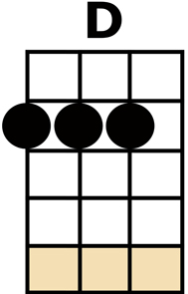
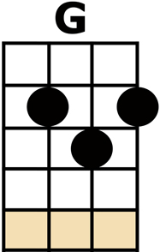
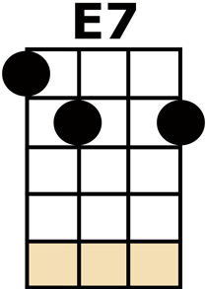
A WILLY NOR A [G] SAM (NO SAM)
I'M HER [E7] EIGHTH OLD [F] MAN, I'M [A] 'ENERY
[D] 'ENERY THE [G] EIGHTH I [C] AM.
{ALL SHOUT} "SECOND VERSE, SAME AS THE FIRST..."
[C] I'M 'ENERY THE EIGHTH, I AM
[F] 'ENERY THE EIGHTH, I [C] AM, I AM
[C] I GOT MARRIED TO THE WIDOW NEXT DOOR
[D] SHE'S BEEN MARRIED SEVEN [G] TIMES BEFORE
AND [C] EVERY ONE WAS AN [G] 'ENERY ('ENERY)
SHE [F] WOULDN'T HAVE A WILLY
NOR A [G] SAM (NO SAM)
I'M HER [E7] EIGHTH OLD [F] MAN, I'M [A] 'ENERY
[D] 'ENERY THE [G] EIGHTH I [C] AM.

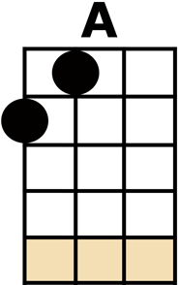
{INSTRUMENTAL VERSE WITH KAZOO'S}
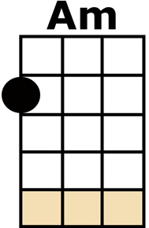
[C] I'M 'ENERY THE EIGHTH, I AM
[F] 'ENERY THE EIGHTH, I [C] AM, I AM
[C] I GOT MARRIED TO THE WIDOW NEXT DOOR
[D] SHE'S BEEN MARRIED SEVEN [G] TIMES BEFORE
AND [C] EVERY ONE WAS AN [G] 'ENERY ('ENERY)
SHE [F] WOULDN'T HAVE A WILLY
NOR A [G] SAM (NO SAM)
I'M HER [E7] EIGHTH OLD [F] MAN, I'M [A] 'ENERY
[D] 'ENERY THE [G] EIGHTH I [C] AM.
[C] "H"-"E" - "N-R-Y" ... [C] 'ENERY ('ENERY)
[Am] 'ENERY ('ENERY)
[C] 'ENERY THE [G] EIGHTH I [Am] AM, I [F] AM
[D] 'ENERY THE [G] EIGHTH I [C] AM! [G/] [C/]

