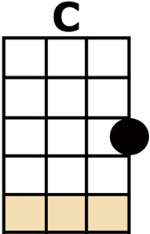
JAMBALAYA

[C] GOODBYE JOE, ME GOTTA GO, ME OH [G] MY OH
ME GOTTA GO, POLE THE [G7] PIROGUE
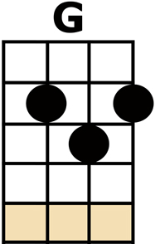
DOWN THE [C] BAYOU
MY YVONNE, THE SWEETEST ONE, ME OH [G] MY OH
SON OF A [G7] GUN,
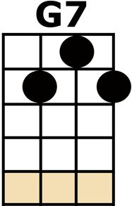
WE'LL HAVE BIG [G] FUN ON THE [C] BAYOU
[C] JAMBALAYA, CRAWFISH PIE AND FILLET [G] GUMBO
'CAUSE TONIGHT I'M GONNA
[G7] SEE MY MA CHER A-[C]-MIO
PICK GUITAR, FILL FRUIT JAR AND BE [G] GAY-O,
SON OF A [G7] GUN,
WE'LL HAVE BIG [G] FUN ON THE [C] BAYOU
[C] THIBODAUX, FONTAINEAUX, THE PLACE IS [G] BUZZIN'
KINFOLK COME TO SEE [G7] YVONNE BY THE [C] DOZEN
DRESS IN STYLE, GO HOG WILD, ME OH [G] MY OH
SON OF A [G7] GUN, WE'LL HAVE BIG [G] FUN ON THE [C] BAYOU
[C] JAMBALAYA, CRAWFISH PIE AND FILLET [G] GUMBO
'CAUSE TONIGHT I'M GONNA [G7] SEE MY MA CHER A-[C]-MIO
PICK GUITAR, FILL FRUIT JAR AND BE [G] GAY-O,
SON OF A [G7] GUN, WE'LL HAVE BIG [G] FUN ON THE [C] BAYOU
[C] SETTLE DOWN FAR FROM TOWN GET ME A [G] PIROGUE
AND I'LL CATCH ALL THE [G7] FISH IN THE [C] BAYOU
SWAP MY MONEY TO BUY YVONNE WHAT SHE [G] NEED-O
SON OF A [G7] GUN, WE'LL HAVE BIG [G] FUN ON THE [C] BAYOU
[C] JAMBALAYA, CRAWFISH PIE AND FILLET [G] GUMBO
'CAUSE TONIGHT I'M GONNA [G7] SEE MY MA CHER A-[C]-MIO
PICK GUITAR, FILL FRUIT JAR AND BE [G] GAY-O,
SON OF A [G7] GUN, WE'LL HAVE BIG [G] FUN ON THE [C] BAYOU

[C] JAMBALAYA, CRAWFISH PIE AND FILLET [G] GUMBO
'CAUSE TONIGHT I'M GONNA [G7] SEE MY MA CHER A-[C]-MIO
PICK GUITAR, FILL FRUIT JAR AND BE [G] GAY-O,
SON OF A [G7] GUN, WE'LL HAVE BIG [G] FUN ON THE [C] BAYOU
SON OF A [G7] GUN, WE'LL HAVE BIG [G] FUN ON THE [C] BAYOU
[G7/] [C/]

