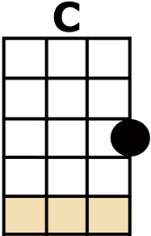
JACKSON

ALL:-
[C] WE GOT MARRIED IN A FEVER,
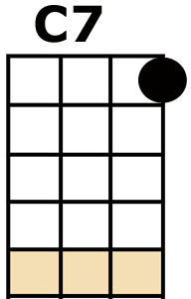
HOTTER THAN A PEPPERED SPROUT,
WE'VE BEEN TALKIN' 'BOUT ..... JACKSON,
[C7] EVER SINCE THE FIRE WENT OUT.
I'M GOIN' TO [F] JACKSON,
I'M GONNA MESS A-[C]-ROUND,
YEAH, I'M GOIN' TO [F] JACKSON
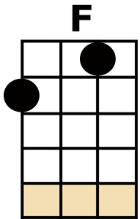
[G7] LOOK OUT JACKSON [C] TOWN.
GIRLS:-
[C] WELL, GO ON DOWN TO JACKSON;
GO AHEAD AND WRECK YOUR HEALTH.
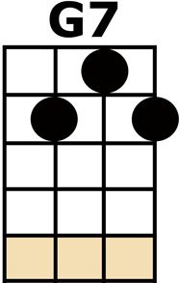
BOYS:- (HUH)
GIRLS:- GO PLAY YOUR HAND YOU BIG-TALKIN' MAN,
MAKE A [C7] BIG FOOL OF YOURSELF,
YEAH GO TO [F] JACKSON; GO COMB YOUR [C] HAIR!
BOYS:- I'M GONNA SNOWBALL [F] JACKSON.
GIRLS:- [G7] SEE IF I [C] CARE.
BOYS:-
[C] WHEN I BREEZE INTO THAT CITY,
PEOPLE GONNA STOOP AND BOW.
GIRLS:- (HAH!)
BOYS:- ALL THEM WOMEN GONNA MAKE ME,
[C7] TEACH 'EM WHAT THEY DON'T KNOW HOW,
I'M GOIN' TO [F] JACKSON, YOU TURN TO LOOSEN MY [C] COAT.
'COS I'M GOIN' TO [F] JACKSON.
GIRLS:- [G7] "GOODBYE!"
BOYS:- THAT'S ALL SHE [C] WROTE.
GIRLS:-
[C] BUT THEY'LL LAUGH AT YOU IN JACKSON,
AND I'LL BE DANCIN' ON A PONY KEG.
THEY'LL LEAD YOU 'ROUND LIKE A SCALDED HOUND,
WITH YOUR [C7] TAIL TUCKED BETWEEN YOUR LEGS,
YEAH GO TO [F] JACKSON, YOU BIG-TALKIN' [C] MAN.
AND I'LL BE WAITIN' IN [F] JACKSON
[G7] BEHIND MY JAYPAN [C] FAN
ALL:-
[C] WE GOT MARRIED IN A FEVER,
HOTTER THAN A PEPPERED SPROUT,
WE'VE BEEN TALKIN' 'BOUT .... JACKSON,
[C7] EVER SINCE THE FIRE WENT OUT.
I'M GOIN' TO [F] JACKSON, AND THAT'S A [C] FACT.
YEAH, WE'RE GOIN' TO [F] JACKSON,
[G7] AIN'T NEVER COMIN' [C] BACK.

