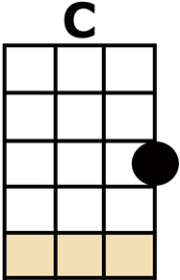
LAND OF DREAMS

[C/] {Acapella}
I HEARD YOU [F] CALLING FROM THE [C] START
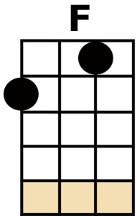
A RIVER [G] RUNS THROUGH BOTH OUR [Am] HEARTS
A THOUSAND [F] SHADES OF SOMETHING [C] NEW
I CANNOT [G] WAIT TO PLAY FOR [C] YOU

[F][C][G][C]
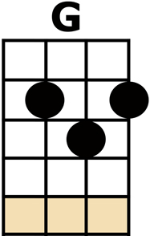
SO PLAY YOUR [F] SONGS AND MAKE THEM [C] REAL
THERE'S A [G] PLACE FOR ALL WE [Am] FEEL
AND IT'S [F] CLOSER THAN IT [C] SEEMS
COME AND [G] FIND YOUR LAND OF [C] DREAMS
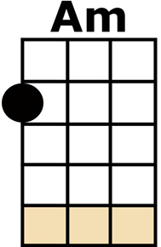
CHORUS:
LAND OF [F] DREAMS, LAND OF [C] DREAMS
COME AND [G] FIND YOUR LAND OF [C] DREAMS
AND IT'S [F] CLOSER THAN IT [C] SEEMS
COME AND [G] FIND YOUR LAND OF [C] DREAMS

THE WORLD IS [F] SMALLER IN OUR [C] EYES
THE CITY [G] STREETS AND MOONLIT [Am] SKIES
THE SHINING [F] WAVES AND EVER-[C]-GREENS
I WILL [G] GIVE YOU EVERY-[C]-THING

YOU CAN [F] HEAR THE BELLS AND [C] STRINGS
JUST WAIT UN-[G]-TIL YOU MAKE THEM [Am] RING
AND IT'S [F] CLOSER THAN IT [C] SEEMS
COME AND [G] FIND YOUR LAND OF [C] DREAMS

CHORUS

I HEARD YOU [F] CALLING FROM THE [C] START
A RIVER [G] RUNS THROUGH BOTH OUR [Am] HEARTS
A THOUSAND [F] SHADES OF SOMETHING [C] NEW
I CANNOT [G] WAIT TO PLAY FOR [C] YOU

SO PLAY YOUR [F] SONGS AND MAKE THEM [C] REAL
THERE'S A [G] PLACE FOR ALL WE [Am] FEEL
AND IT'S [F] CLOSER THAN IT [C] SEEMS
COME AND [G] FIND YOUR LAND OF [C] DREAMS

CHORUS x2

