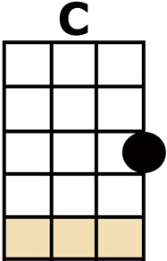
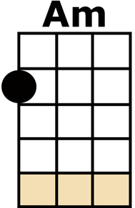
MATCHSTALK MEN AND MATCHSTALK CATS AND DOGS

HE [C] PAINTED SALFORDS SMOKEY TOPS
ON [Am] CARDBOARD BOXES FROM THE SHOP
AND [A] PARTS OF ANCOATS [A7] WHERE I USED TO [Dm] PLAY
I'M [F] SURE HE ONCE WALKED DOWN OUR STREET
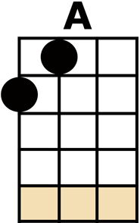
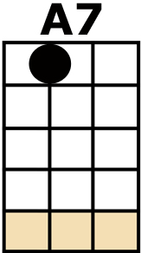
'COS HE [C] PAINTED KIDS WHO HAD NOWT ON THEIR FEET
THE [G] CLOTHES THEY WORE HAD ALL SEEN BETTER [C] DAYS.

NOW THEY [C] SAID HIS WORKS OF ART WERE DULL,
"NO [Am] ROOM OWD LAD, THE WALLS ARE FULL"
BUT [A] LOWRY DIDN'T [A7] CARE MUCH ANY-[Dm]-WAY,
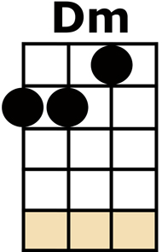
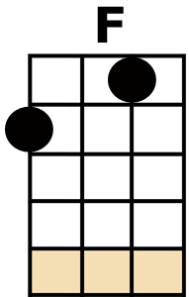
THEY [F] SAID "HE JUST PAINTS CATS AND DOGS,
AND [C] MATCHSTALK MEN IN BOOTS AND CLOGS"
AND [G] LOWRY SAID "THAT'S JUST THE WAY THEY'LL [C] STAY"

CHORUS:
AND HE PAINTED [C] MATCHSTALK MEN
AND MATCHSTALK CATS AND [F] DOGS,
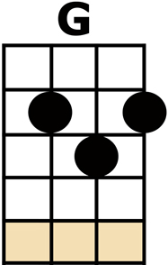
HE PAINTED [G] KIDS ON THE CORNER OF THE STREET
THAT WERE SPARKING [C] CLOGS,
NOW HE TAKES HIS BRUSH AND HE WAITS
OUT-[F]-SIDE THEM FACTORY GATES TO PAINT HIS
[G] MATCHSTALK MEN AND MATCHSTALK CATS AND [C] DOGS.

NOW [C] CANVAS AND BRUSHES WERE WEARING THIN
WHEN [Am] LONDON STARTED CALLING HIM
TO [A] COME ON DOWN AND [A7] WEAR THE OLD FLAT [Dm] CAP,
THEY SAID [F] "TELL US ALL ABOUT YOUR WAYS,
AND [C] ALL ABOUT THEM SALFORD DAYS,
IS IT [G] TRUE YOU'RE JUST AN ORDINARY [C] CHAP?"

CHORUS

NOW [C] LOWRYS HANG UPON THE WALL
BE-[Am]-SIDE THE GREATEST OF THEM ALL
AND [A] EVEN THE MONA [A7] LISA TAKES A [Dm] BOW,
THIS [F] TIRED OLD MAN WITH HAIR LIKE SNOW
TOLD [C] NORTHERN FOLK IT'S TIME TO GO,
THE [G] FEVER CAME AND THE GOOD LORD MOPPED HIS [C] BROW

{THE BIG SHIP SAILS THROUGH THE ALLY-ALLY-O,
THE ALLY-ALLY-O}
AND HE LEFT US [C] MATCHSTALK MEN
AND MATCHSTALK CATS AND [F] DOGS,
HE LEFT US [G] KIDS ON THE CORNER OF THE STREET
THAT WERE SPARKING [C] CLOGS,
NOW HE TAKES HIS BRUSH AND HE WAITS
OUT-[F]-SIDE THEM PEARLY GATES TO PAINT HIS
[G] MATCHSTALK MEN AND MATCHSTALK CATS AND [C] DOGS.

REPEAT FROM {THE BIG SHIP SAILS ...

