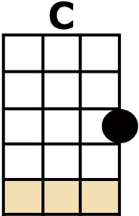
NEW YORK GIRLS INTRO: {C F G C Am F G C} x2

[C] AS I WALKED DOWN TO [F] NEW YORK TOWN,
A [G] FAIR MAID I DID [C] MEET
SHE [Am] ASKED ME BACK TO [F] SEE HER PLACE,
SHE [G] LIVED ON BARRACK [C] STREET
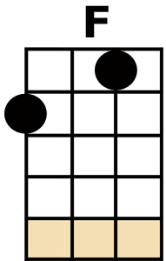
CHORUS:
[C] AND AWAY, [F] SANTY, [G] MY DEAR [C] ANNIE
[C] OH, YOU [F] NEW YORK GIRLS,
[G] CAN'T YOU DANCE THE [C] POLKA?

[C] AND WHEN WE GOT TO [F] BARRACK STREET,
WE [G] STOPPED AT FORTY-[C]-FOUR
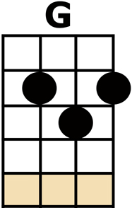
HER [Am] MOTHER AND HER [F] SISTER
WERE [G] WAITING AT THE [C] DOOR

CHORUS {C F G C} {C F G C}

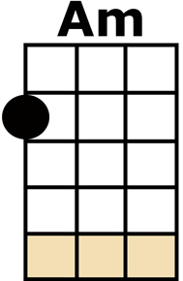
[C] AND WHEN I GOT IN-[F]-SIDE THE HOUSE,
THE [G] DRINKS WERE PASSED A-[C]-ROUND
THE [Am] LIQUOR WAS SO [F] AWFUL STRONG;
MY [G] HEAD WENT ROUND AND [C] ROUND
AND [C] THEN WE HAD A-[F]-NOTHER DRINK
BE-[G]-FORE WE SAT TO [C] EAT
THE [Am] LIQUOR WAS SO [F] AWFUL STRONG,
I [G] QUICKLY FELL A-[C]-SLEEP

CHORUS {C F G C} {C F G C}

[C] WHEN I AWOKE NEXT [F] MORNING,
I [G] HAD AN ACHING [C] HEAD
AND [Am] THERE WAS I JACK [F] ALL ALONE,
STARK [G] NAKED IN ME [C] BED
MY [C] GOLD WATCH AND MY [F] MONEY
AND MY [G] LADY FRIEND WERE [C] GONE
AND [Am] THERE WAS I JACK [F] ALL ALONE,
STARK [G] NAKED IN THE [C] ROOM

CHORUS {C F G C} {C F G C}

OH [C] LOOKING ROUND THAT [F] LITTLE ROOM,
THERE'S [G] NOTHING I COULD [C] SEE
BUT A [Am] WOMAN'S SHIFT AND [F] APRON,
THAT [G] WERE NO USE TO [C] ME
WITH A [C] BARREL FOR A [F] SUIT OF CLOTHES,
DOWN [G] CHERRY STREET FOR-[C]-LORN
WHERE [Am] MARTIN CHURCHILL [F] TOOK ME IN AND HE
[G] SENT ME ROUND CAPE [C] HORN

SO [C] SAILOR LADS TAKE [F] WARNING
WHEN YOU [G] LAND ON NEW YORK'S [C] SHORE
YOU'LL [Am] HAVE TO GET UP [F] EARLY
TO BE [G] SMARTER THAN A [C/] WHORE ...

CHORUS CHORUS
{C F G C} {C F G C}

