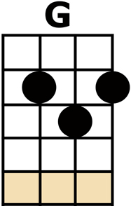
PAY ME MY MONEY DOWN

CHORUS:
[G] PAY ME, PAY ME,
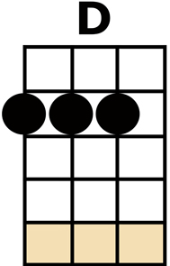
PAY ME MY [D] MONEY DOWN,
PAY ME OR GO TO JAIL,
PAY ME MY [G] MONEY DOWN

[G] I THOUGHT I HEARD THE CAPTAIN SAY,
PAY ME MY [D] MONEY DOWN,
TOMORROW IS OUR SAILING DAY,
PAY ME MY [G] MONEY DOWN

SOON AS THAT BOAT WAS CLEAR OF THE BAR,
PAY ME MY [D] MONEY DOWN,
IT KNOCKED ME DOWN, WITH A SPAR,
PAY ME MY [G] MONEY DOWN

CHORUS

IF I’D BEEN A RICH MAN’S SON,
PAY ME MY [D] MONEY DOWN,
I’D SIT ON THE RIVER AND WATCH IT RUN,
PAY ME MY [G] MONEY DOWN

CHORUS THEN KAZOO INSTRUMENTAL VERSE

WELL I WISH I WAS, MR GATES,
PAY ME MY [D] MONEY DOWN,
THEY’D HAUL MY MONEY IN IN CRATES,
PAY ME MY [G] MONEY DOWN

CHORUS

WELL FORTY NIGHTS, NIGHTS AT SEA,
PAY ME MY [D] MONEY DOWN,
CAP'N WORKED EV'RY LAST DOLLAR OUT A' ME,
PAY ME MY [G] MONEY DOWN

CHORUS x2 then:
[D] PAY ME OR GO TO JAIL,
PAY ME MY [G/] MONEY [G/] DOWN

