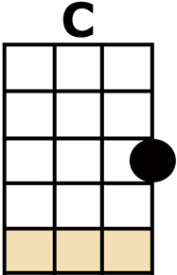
THE STREETS OF LONDON

[C] HAVE YOU SEEN THE [G] OLD MAN
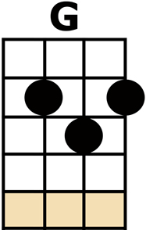
IN THE [Am] CLOSED-DOWN [G] MAR-[Em]-KET
[F] KICKING UP THE [C] PAPER,
WITH HIS [D] WORN OUT [G] SHOES?
[C] IN HIS EYES YOU [G] SEE NO PRIDE
[Am] HAND HELD LOOSELY [G] AT HIS [Em] SIDE
[F] YESTERDAY'S [C] PAPER
TELLING [G] YESTERDAY'S [C] NEWS [C]
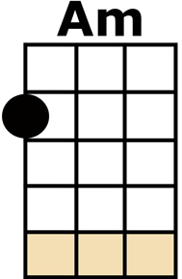
[C] HAVE YOU SEEN THE [G] OLD GIRL
WHO [Am] WALKS THE STREETS OF [G] LON-[Em]-DON
[F] DIRT IN HER [C] HAIR
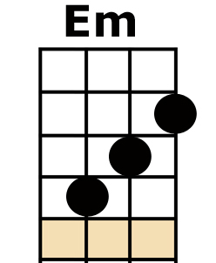
AND HER [D] CLOTHES IN [G] RAGS?
[C] SHE'S NO TIME FOR [G] TALKING,
SHE [Am] JUST KEEPS RIGHT ON [G] WALK-[Em]-ING
[F] CARRYING HER [C] HOME
IN TWO [G] CARRIER [C] BAGS [C]
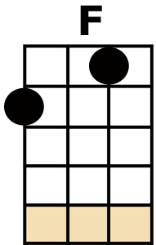
CHORUS:
SO [F] HOW CAN YOU [C] TELL ME YOU'RE [G] LONE-[C]-LY,
AND [D] SAY FOR YOU THAT THE SUN DON'T [G] SHINE?
[C] LET ME TAKE YOU [G] BY THE HAND AND
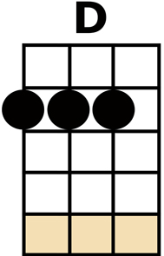
[Am] LEAD YOU THROUGH THE [G] STREETS OF [Em] LONDON
[F] I'LL SHOW YOU [C] SOMETHING TO
[G] MAKE YOU CHANGE YOUR [C] MIND

[C] IN THE ALL NIGHT [G] CAFE
AT A [Am] QUARTER PAST [G] EL-[Em]-EVEN
[F] SAME OLD [C] MAN SITTING [D] THERE ON HIS [G] OWN
[C] LOOKING AT THE [G] WORLD
OVER THE [Am] RIM OF HIS [G] TEA [Em] CUP,
[F] EACH TEA LASTS AN [C] HOUR
THEN HE [G] WANDERS HOME A-[C]-LONE [C]

CHORUS

[C] HAVE YOU SEEN THE [G] OLD MAN
OUT-[Am]-SIDE THE SEAMAN'S [G] MISS-[Em]-ION
[F] MEM'RY [C] FADIN' WITH THE MEDAL
[D] RIBBONS THAT HE [G] WEARS
[C] IN OUR WINTER [G] CITY,
THE RAIN [Am] CRIES A LITTLE [G] PIT-[Em]-Y
FOR ONE [F] MORE FORGOTTEN [C] HERO
AND A [G] WORLD THAT DOESN'T [C] CARE [C]

CHORUS [G] [C/]

