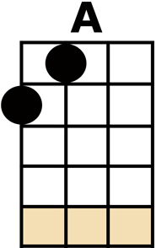
THESE BOOTS ARE MADE FOR WALKING

[RIFF ON 'C' STRING 9-9-8-8-7-7-6-6-5-5-4-4-3-3-2-0]

[A] YOU KEEP SAYING YOU GOT SOMETHING FOR ME
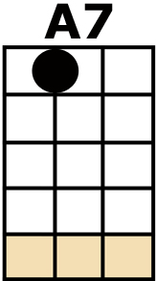
SOMETHING YOU CALL LOVE BUT CON-[A7]-FESS
[D] YOU'VE BEEN MESSIN'
WHERE YOU SHOULDN'T HAVE BEEN A-MESSIN'
AND NOW [A] SOMEONE ELSE
IS GETTING ALL YOUR BEST

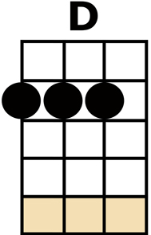
THESE [C] BOOTS ARE MADE FOR [A] WALKING,
AND [C] THAT'S JUST WHAT THEY'LL [A] DO
[C] ONE OF THESE DAYS THESE [A/] BOOTS
{NO CHORD} ARE GONNA WALK ALL OVER YOU
[RIFF ON 'C' STRING 9-9-8-8-7-7-6-6-5-5-4-4-3-3-2-0]
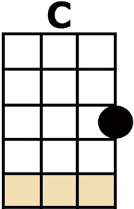
[A] YOU KEEP LYING WHEN YOU OUGHTA BE TRUTHIN'
YOU KEEP LOSING WHEN YOU OUGHTA NOT [A7] BET
[D] YOU KEEP SAMIN'
WHEN YOU OUGHTA BE A'CHANGIN'
NOW WHAT'S [A] RIGHT IS RIGHT
BUT YOU AIN'T BEEN RIGHT YET

THESE [C] BOOTS ARE MADE FOR [A] WALKING,
AND [C] THAT'S JUST WHAT THEY'LL [A] DO
[C] ONE OF THESE DAYS THESE [A/] BOOTS
{NO CHORD} ARE GONNA WALK ALL OVER YOU
[RIFF ON 'C' STRING 9-9-8-8-7-7-6-6-5-5-4-4-3-3-2-0]

[A] YOU KEEP PLAYING
WHERE YOU SHOULDN'T BE PLAYING
AND YOU KEEP THINKING
THAT YOU'LL NEVER GET [A7] BURNT (HAH!)
[D] I JUST FOUND ME
A BRAND NEW BOX OF MATCHES (YEAH)
AND [A] WHAT HE KNOWS
YOU AIN'T HAD TIME TO LEARN

THESE [C] BOOTS ARE MADE FOR [A] WALKING,
AND [C] THAT'S JUST WHAT THEY'LL [A] DO
[C] ONE OF THESE DAYS THESE [A/] BOOTS
{NO CHORD} ARE GONNA WALK ALL OVER YOU
[RIFF ON 'C' STRING 9-9-8-8-7-7-6-6-5-5-4-4-3-3-2-0]

[A] ARE YOU READY, BOOTS? ....... START WALKIN'
KAZOO TO END 'DA DA DA DA'

