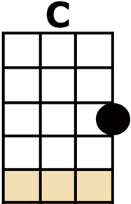
THREE LITTLE BIRDS/ DON'T WORRY BE HAPPY

CHORUS:
DON'T [C] WORRY, ABOUT A THING
CAUSE' [F] EVERY LITTLE THING,
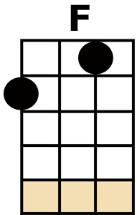
GONNA BE AL-[C]-RIGHT
SINGIN' DON'T [C] WORRY, ABOUT A THING
CAUSE' [F] EVERY LITTLE THING,
GONNA BE AL-[C]-RIGHT

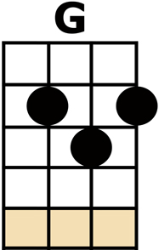
RISE UP THIS [C] MORNIN',
SMILE WITH THE [G] RISING SUN
THREE LITTLE [C] BIRDS
PERCH BY MY [F] DOORSTEP
SINGIN' [C] SWEET SONGS
OF MELODYS [G] PURE AND TRUE, SAYIN',
[F] "THIS IS MY MESSAGE TO [C] YOU-OO-OO"

CHORUS

[C] HERE'S A LITTLE SONG I WROTE
[G] YOU MIGHT WANT TO SING IT NOTE FOR NOTE
DON'T [F] WORRY, BE [C] HAPPY.
[C] IN EVERY LIFE WE HAVE SOME TROUBLE
[G] WHEN YOU WORRY YOU MAKE IT DOUBLE
DON'T [F] WORRY, BE [C] HAPPY.
[C] DON'T WORRY BE HAPPY-

CHORUS

[C] AIN'T GOT NO PLACE TO LAY YOUR HEAD
[G] SOMEBODY CAME AND TOOK YOUR BED
DON'T [F] WORRY, BE [C] HAPPY.
[C] THE LANDLORD SAY YOUR RENT IS LATE
[G] HE MAY HAVE TO LITIGATE
DON'T [F] WORRY, BE [C] HAPPY.
[C] DON'T WORRY BE HAPPY -

CHORUS

[C] AIN'T GOT NO CASH, AIN'T GOT NO STYLE
[G] AIN'T GOT NO GAL TO MAKE YOU SMILE
DON'T [F] WORRY, BE [C] HAPPY.
[C] 'CAUSE WHEN YOU WORRY YOUR FACE WILL FROWN
[G] AND THAT WILL BRING EVERYBODY DOWN
DON'T [F] WORRY, BE [C] HAPPY.
[C] DON'T WORRY BE HAPPY-

CHORUS THEN: {acapella}: "DON'T WORRY BE HAPPY NOW!"

