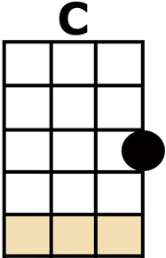
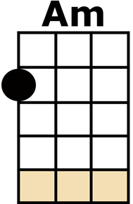
UNDER THE MOON OF LOVE

KAZOO intro: [C] [Am] [C] [Am]
[C] LET'S GO FOR A LITTLE WALK
[Am] UNDER THE MOON OF LOVE
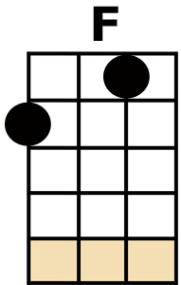
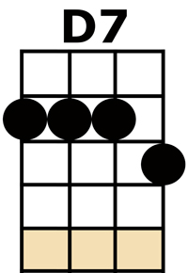
[C] LET'S SIT DOWN AND TALK
[Am] UNDER THE MOON OF LOVE
I WANNA [F/] TELL YA [F//] THAT I [D7/] LOVE YA [D7//]
AND I [C] WANT YOU TO BE MY [A] GIRL,
LITTLE DARLING LET'S [D7] WALK, LET'S TALK,
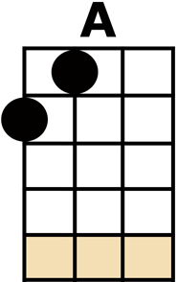
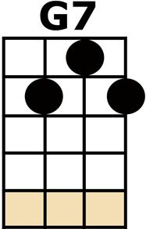
[G7] UNDER THE MOON OF [C] LOVE (THE [F] MOON OF [C] LOVE)

[C] YOU WERE LOOKING SO LOVELY
[Am] UNDER THE MOON OF LOVE
[C] YOUR EYES SHINE SO BRIGHTLY
[Am] UNDER THE MOON OF LOVE
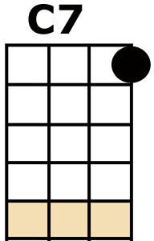
I WANNA [F/] GO [F//] ALL THE [D7/] TIME [D7//]
YOU'LL [C] BE MY LOVE TO-[A]-NIGHT,
LITTLE DARLING LET'S [D7] WALK, LET'S TALK,
[G7] UNDER THE MOON OF [C] LOVE (THE [F] MOON OF [C] LOVE)

I WANNA [F] TALK SWEET TALK,
AND WHISPER THINGS IN YOUR [C] EARS... [C7]
I WANNA [D7] TELL YOU LOTS OF THINGS
I KNOW YOU'VE BEEN LONGING TO [G7] HEAR...
(COME ON LITTLE DARLING, TAKE MY HAND)

[C] LET'S GO FOR A LITTLE WALK
[Am] UNDER THE MOON OF LOVE
[C] LET'S SIT DOWN AND TALK
[Am] UNDER THE MOON OF LOVE
I WANNA [F/] TELL YA [F//] THAT I [D7/] LOVE YA [D7//]
AND I [C] WANT YOU TO BE MY [A] GIRL,
LITTLE DARLING LET'S [D7] WALK, LET'S TALK,
[G7] UNDER THE MOON OF [C] LOVE (THE [F] MOON OF [C] LOVE)

KAZOO solo: [C] [Am] [C] [Am]
I WANNA [F/] TELL YA [F//] THAT I [D7/] LOVE YA [D7//]
AND I [C] WANT YOU TO BE MY [A] GIRL,
LITTLE DARLING LET'S [D7] WALK, LET'S TALK,
[G7] UNDER THE MOON OF [C] LOVE (THE [F] MOON OF [C] LOVE)

I WANNA [F] TALK SWEET TALK,
AND WHISPER THINGS IN YOUR [C] EARS... [C7]
I WANNA [D7] TELL YOU LOTS OF THINGS
I KNOW YOU'VE BEEN LONGING TO [G7] HEAR...
(COME ON LITTLE DARLING, TAKE MY HAND)

[C] LET'S GO FOR A LITTLE WALK [Am] UNDER THE MOON OF LOVE
[C] LET'S SIT DOWN AND TALK [Am] UNDER THE MOON OF LOVE
I WANNA [F/] TELL YA [F//] THAT I [D7/] LOVE YA [D7//]
AND I [C] WANT YOU TO BE MY [A] GIRL,
LITTLE DARLING LET'S [D7] WALK, LET'S TALK,
[G7] UNDER THE MOON OF [C] LOVE (THE [F] MOON OF [C] LOVE)
[F/][C/]

