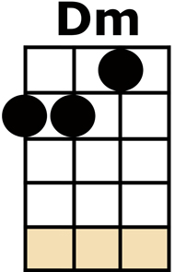
UPSIDE DOWN

intro: [Dm] [Dm] [Dm] [Dm] [Gm] [Gm] [Gm] [Gm]

[Dm] ANGELS WATCHING OVER ME WITH SMILES UPON THEIR FACE
'COZ [Gm] I HAVE MADE IT THROUGH THIS FAR IN AN
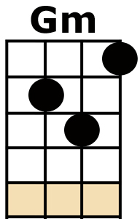
UNFORGIVING PLACE - IT [Dm] FEELS SOMETIMES THIS IS TOO STEEP
FOR A GIRL LIKE ME TO CLIMB
BUT [Gm] I MUST KNOCK THOSE GUARDS RIGHT DOWN,
I DO IT IN MY OWN TIME

I DON'T [A] CARE (CARE CARE) I'M HALF WAY [Gm] THERE (NOWHERE)
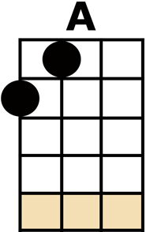
ON A [A] ROAD THAT LEADS ME TO STRAIGHT TO WHO KNOWS WHERE [A/]
Girls: I TELL YOU [Dm] WHAT Guys:(I TELL YOU WHAT)
WHAT I HAVE [Am] FOUND (WHAT I HAVE FOUND)
THAT I'M NO [Gm] FOOL (THAT I'M NO FOOL)
I'M JUST UPSIDE [Dm] DOWN (JUST UPSIDE DOWN)
[Dm] AIN'T GOT NO PAIN (AIN'T GOT NO PAIN)
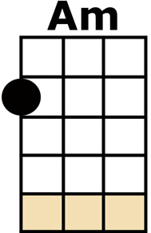
I AINT GOT NO [Am] RULES (AINT GOT NO RULES)
I THINK I [Gm] LIKE (I THINK I LIKE)
LIVING UPSIDE [Dm] DOWN (LIVING UPSIDE DOWN)

[Dm] WATCHIN PEOPLE SCURRY BY RUSHING TO AND FRO
OH THIS [Gm] WORLD IS SUCH A CRAZY PLACE
IT'S ALL ABOUT THE [Gm/] GO! [Gm/] GO! [Gm/] GO!
[Dm] SOMETIMES LIFE CAN TASTE SO SWEET WHEN YOU SLOW IT DOWN
YOU [Gm] START TO SEE THE WORLD A LITTLE DIFFERENTLY
WHEN YOU TURN IT UPSIDE DOWN

I DON'T [A] CARE (CARE CARE) I'M HALF WAY [Gm] THERE (NOWHERE)
AND I'M JUST [A] SOAKING UP THE MAGIC IN THE AIR [A/]
Girls: I TELL YOU [Dm] WHAT Guys:(I TELL YOU WHAT)
WHAT I HAVE [Am] FOUND (WHAT I HAVE FOUND)
THAT I'M NO [Gm] FOOL (THAT I'M NO FOOL)
I'M JUST UPSIDE [Dm] DOWN (JUST UPSIDE DOWN)
[Dm] AIN'T GOT NO PAIN (AIN'T GOT NO PAIN)
I AINT GOT NO [Am] RULES (AINT GOT NO RULES)
I THINK I [Gm] LIKE (I THINK I LIKE)
LIVING UPSIDE [Dm] DOWN (LIVING UPSIDE DOWN)

[Dm] (WHOA WHOA WHOA) YOU GOTTA SLOW IT DOWN [Am] (YEAH YEAH YEAH)
BUT THEN YOU PICK IT UP [Gm] (WHOA YEAH WHOA) C'MON AND TRY A LITTLE
[Dm] TOPSY-TURVY BACK-TO-FRONT THE RIGHT WAY ROUND
[Dm] TAKE IT SLOW, SLOW, SLOW, (YOU GOTTA PICK IT UP)
[Am] YEAH, YEAH, YEAH, (SEE YOU SLOW IT DOWN)
[Gm] YO, YO, YO, (TELL ME SOMETHING ... [Dm] [Dm/] SOME-[Dm/]-THING)

Girls: I TELL YOU [Dm] WHAT Guys:(I TELL YOU WHAT)
WHAT I HAVE [Am] FOUND (WHAT I HAVE FOUND)
THAT I'M NO [Gm] FOOL (THAT I'M NO FOOL)
I'M JUST UPSIDE [Dm] DOWN (JUST UPSIDE DOWN)
[Dm] AIN'T GOT NO PAIN (AIN'T GOT NO PAIN)
I AINT GOT NO [Am] RULES (AINT GOT NO RULES)
I THINK I [Gm] LIKE (I THINK I LIKE)
LIVING UPSIDE [Dm] DOWN (LIVING UPSIDE DOWN)
repeat last chorus, then [Dm/][Dm/]

