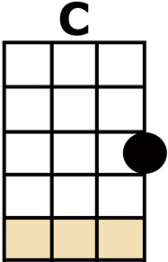
YOU BELONG TO ME
[C] I TAKE THE NIGHT TRAIN, I TAKE AN AIRPLANE
CAUSE [Am] YOU BE-[G]-LONG TO [C] ME
[C] I JUST WANNA SAY
AIN'T GONNA LET YOU GET AWAY
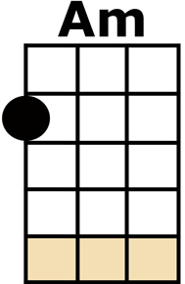
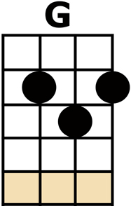
CAUSE [Am] YOU BE-[G]-LONG TO [C] ME
I ONLY WANNA [Am] HO-[G]-O-[C]-OLD [F] YOU
I JUST WANNA [Am] HO-[G]-O-[C]-OLD [F] YOU
COME ON LET ME [Am] HO-[G]-O-[C]-OLD [F] YOU
[C] TONIGHT
[C] YOU SAY YOU AIN'T LEAVING
I CAN'T HELP DREAMING
CAUSE [Am] YOU BE-[G]-LONG TO [C] ME
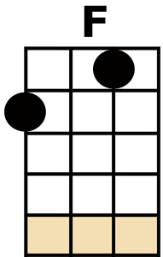
I'LL TAKE THAT HIGHWAY, I'LL TAKE THE LOW WAY
CAUSE [Am] YOU BE-[G]-LONG TO [C] ME
I ONLY WANNA [Am] HO-[G]-O-[C]-OLD [F] YOU
I JUST WANNA [Am] HO-[G]-O-[C]-OLD [F] YOU
COME ON LET ME [Am] HO-[G]-O-[C]-OLD [F] YOU
[C] TONIGHT
[C] I'M NOT DRINKING, IT GETS ME THINKING
THAT [Am] YOU BE-[G]-LONG TO [C] ME
WHILE YOU'RE OUT THERE, REMEMBER I'M RIGHT HERE
AND [Am] YOU BE-[G]-LONG TO [C] ME

I ONLY WANNA [Am] HO-[G]-O-[C]-OLD [F] YOU
I JUST WANNA [Am] HO-[G]-O-[C]-OLD [F] YOU
COME ON LET ME [Am] HO-[G]-O-[C]-OLD [F] YOU
[C] TONIGHT

[C] I TAKE THE NIGHT TRAIN, I TAKE AN AIRPLANE
CAUSE [Am] YOU BE-[G]-LONG TO [C] ME
[C] I JUST WANNA SAY
AIN'T GONNA LET YOU GET AWAY
CAUSE [Am] YOU BE-[G]-LONG TO [C] ME
I ONLY WANNA [Am] HO-[G]-O-[C]-OLD [F] YOU
I JUST WANNA [Am] HO-[G]-O-[C]-OLD [F] YOU
COME ON LET ME [Am] HO-[G]-O-[C]-OLD [F] YOU
COME ON LET ME [Am] HO-[G]-O-[C]-OLD [F] YOU
[C/] TONIGHT

